PEGA PLATFORM STUDIOS

* Pega Platform is a low-code application development platform that allows organizations to quickly build and deploy enterprise applications with minimal coding effort. Pega Platform provides a wide range of tools and features to design, develop, and manage applications, and one of its key components is Pega Studio, which encompasses various studios for different aspects of application development. Here, we'll discuss Pega Platform Studios in detail:
* **Workspaces**: A workspace is an environment that provides specific tools and features. By using different workspaces to develop and manage your application, you can help team members focus on the tasks that align with their expertise.
* Pega provides four role-based authoring workspaces:
* APP STUDIO
* DEV STUDIO
* ADMIN STUDIO
* PREDECTION STUDIO
* APP STUDIO:
* App Studio is a core component of Pega Platform that is specifically designed for business analysts, application designers, and other non-technical users. It empowers these users to create and configure applications without extensive coding, making it a critical tool in Pega's low-code development environment. Here's a detailed explanation of App Studio's key features and functionalities:

1. Case Design and Modeling:

* Case Designer: In App Studio, you can define and design the lifecycles of cases, which represent various processes, workflows, or transactions within your application.
* Stage and Step Design: Create stages and steps within cases, outlining the progression of work and specifying the actions and data required at each step.

2. Data Modeling:­­­­­­­­­­­­

* Data Designer: App Studio includes tools for defining and managing the data model of your application, including entities, properties, relationships, and data types.
* Data Integration: You can easily integrate with external data sources and services to access and update data from external systems.

3. User Interface (UI) Design:

* UI Designer: App Studio provides a visual interface for building user interfaces, forms, and screens through a drag-and-drop approach.
* Responsive Design: Create responsive and user-friendly interfaces that adapt to different devices and screen sizes.
* Reusable Components: Develop and reuse UI components to maintain consistency across the application.

4. App Logic and Automation:

* Declarative Logic: Configure application behavior using declarative rules, which allow you to define conditions, validation rules, and calculations without writing code.
* Business Rules: Create and manage business rules that govern how cases are processed, including routing, decision-making, and automation.

5. Collaboration and User Management:

* User and Access Management: App Studio enables administrators to manage user accounts, roles, and access permissions directly from the interface.
* Collaboration Tools: Include collaboration features like discussion boards and case notes to facilitate communication and collaboration among users.

6. Integration and Connectors:

* Connector Integration: You can easily integrate your application with external systems and services using connectors and RESTful APIs.
* Service Rules: Create service rules to define how your application interacts with external services.

7. Testing and Simulation:

* Simulation: Test and simulate case lifecycles and processes to ensure they function as expected before deploying them.
* Debugging: Debug and troubleshoot issues within the application directly from the interface.

8. Deployment and Application Lifecycle:

* Deployment: App Studio offers features for packaging and deploying applications to different environments (e.g., development, testing, production).
* Version Control: Manage versions of your application and track changes.

9. Security and Access Control:

* Access Control: Configure access control policies, authentication mechanisms, and security settings for your application.

10. Reporting and Analytics

* Real-time Reporting: Access real-time reports and dashboards to monitor case performance, user activities, and other metrics.
* App Studio's low-code capabilities make it accessible to a wide range of users, including business analysts and subject matter experts. It empowers them to actively participate in the application development process, accelerating the delivery of business-critical applications while maintaining the flexibility to adapt to changing business needs. Additionally, App Studio promotes collaboration between business and IT teams by providing a common platform for designing and configuring applications.DEV STUDIO:
* **DEV STUDIO**  
  Dev Studio, short for Development Studio, is a key component of Pega Platform that caters to developers and technical professionals. It provides a robust and comprehensive set of tools and capabilities to design, build, test, and deploy custom application components and integrate with external systems. Dev Studio is the go-to environment for developers to work on the underlying code and configurations of Pega applications. Here's a detailed explanation of Dev Studio's primary features and functionalities:

1. **Code Development**:

* **Java Development**: Developers can write custom Java code when necessary to extend the functionality of Pega applications.
* **Scripting**: Use scripting languages, such as JavaScript, to enhance user interfaces and implement custom logic.
* **Custom Functions**: Create reusable custom functions and libraries to streamline development.

1. **Integration and Connectors**:

* **Connector Development**: Dev Studio allows developers to create connectors to integrate with external systems, services, and APIs (e.g., REST, SOAP).
* **Service Rules**: Define service rules to manage interactions with external services and data sources.
* **Database Integration**: Develop database connectors and SQL queries to interact with databases.

1. **Customization**:

* **Custom Activities**: Create custom activities to implement specific business logic and automate tasks.
* **Rules and Processes**: Define decision tables, decision trees, and flows to control application behavior.
* **User Interface Customization**: Customize the user interface by creating custom controls, layouts, and sections.

1. **Security Configuration**:

* **Access Control**: Configure access control rules and policies to manage user access to application components.
* **Authentication**: Set up authentication mechanisms, including LDAP, single sign-on (SSO), and multi-factor authentication (MFA).

1. **Testing and Debugging**:

* **Unit Testing**: Developers can conduct unit testing to validate the functionality of their code and ensure it meets requirements.
* **Debugging**: Dev Studio provides debugging tools to troubleshoot and resolve issues in the code.

1. **Version Control and Collaboration**:

* **Version Control Integration**: Integrate Dev Studio with version control systems like Git for source code management and collaboration.
* **Collaborative Development**: Multiple developers can work on the same application concurrently, promoting collaboration and code reusability.

1. **Performance Optimization**:

* **Performance Monitoring**: Monitor application performance and identify areas for optimization.
* **Caching**: Configure caching strategies to improve application response times.

1. **Deployment and Release Management**:

* **Deployment Packages**: Create deployment packages for moving application changes across different environments (e.g., development, testing, production).
* **Continuous Integration**: Implement continuous integration (CI) and continuous delivery (CD) practices for automated application deployment.

1. **Error and Exception Handling**:

* **Error Handling**: Define error-handling strategies and mechanisms to gracefully handle exceptions in the application.
* **Logging**: Configure logging and auditing to capture relevant information for troubleshooting.

1. **Security and Compliance**:

* **Security Policies**: Implement security policies and best practices to ensure the application's security and compliance with industry standards.
* Dev Studio plays a crucial role in the end-to-end application development process within the Pega Platform. It empowers developers to build custom components, integrate with external systems, optimize performance, and ensure the application's security and reliability. Collaboration between Dev Studio and other studios, such as App Studio and Admin Studio, enables cross-functional teams to work together efficiently to create robust and feature-rich applications.

Top of Form

* **ADMIN STUDIO**:
* Admin Studio is a component of Pega Platform that is designed to provide system administrators with tools and capabilities for efficiently managing and maintaining Pega applications and the underlying platform. Admin Studio offers a user-friendly interface that allows administrators to monitor, configure, and troubleshoot various aspects of their Pega applications. Here's a detailed overview of Admin Studio's key features and functionalities:

1. **Application Monitoring and Analytics**:

* **Dashboard**: Admin Studio provides a central dashboard that gives administrators an overview of the health and performance of their Pega applications. It includes key metrics, charts, and insights.

1. **System and Application Management**:

* **Application Deployment**: Admin Studio allows administrators to manage the deployment of Pega applications, including packaging and deploying new versions.
* **Application Lock and Release**: Administrators can lock and release applications for maintenance or updates.
* **Application Archiving**: It provides tools to archive and manage old or unused applications.
* **Environment Management**: Admin Studio assists in managing different environments (e.g., development, testing, production) and their configurations.

1. **User and Access Management**:

* **User Administration**: Administrators can manage user accounts, roles, and access permissions within the Pega platform.
* **Access Control**: Configure security policies, authentication mechanisms, and access control rules.

1. **System Health and Diagnostics**:

* **Logs and Alerts**: Admin Studio provides access to system logs and alerts for monitoring and troubleshooting.
* **Performance Monitoring**: Monitor system performance and identify bottlenecks or issues.
* **Diagnostics**: Use diagnostic tools to identify and resolve issues with applications.

1. **Application and System Configuration**:

* **Dynamic System Settings**: Configure system-wide settings and parameters.
* **Security Policies**: Define and enforce security policies and rules.
* **Rule Sets**: Manage rule sets, versions, and deployment.
* **Advanced Configuration**: Adjust advanced settings and configurations as needed.

1. **Batch Processing and Job Scheduling**:

* **Job Scheduler**: Admin Studio allows administrators to schedule and monitor batch jobs and processes.
* **Queue Management**: Monitor and manage processing queues for asynchronous processing.

1. **System Health and Upgrade Management**:

* **System Updates and Upgrades**: Admin Studio provides tools for upgrading the Pega platform to the latest version.
* **Hotfix Management**: Apply hotfixes and patches to address known issues.

1. **Security and Compliance**:

* **Security Auditing**: Admin Studio assists in auditing user activities and system changes for compliance purposes.
* **Security Monitoring**: Monitor security events and alerts.

1. **Reports and Analytics**:

* **Report Generation**: Create custom reports and dashboards to track various aspects of system and application performance.
* **Analytics**: Analyze data and trends to make informed decisions.

1. **Integration and Connectors**:

* **Integration Management**: Admin Studio allows administrators to configure and manage integrations with external systems, services, and connectors.
* Admin Studio is a critical tool for system administrators, enabling them to ensure the smooth operation of Pega applications, maintain security, troubleshoot issues, and manage system resources effectively. It provides a centralized and user-friendly interface to perform essential administrative tasks efficiently, reducing the complexity of managing a Pega-based environment.
* PREDECTION STUDIO: As of my last knowledge update in September 2021, Pega's Prediction Studio is a part of Pega Customer Decision Hub, which is an advanced decisioning platform within the Pega Platform. Prediction Studio is a tool within Pega Customer Decision Hub that empowers business analysts and data scientists to create and deploy predictive models without requiring extensive coding or data science expertise. These models are then used to make real-time predictions, recommendations, and decisions within Pega applications. Here's a detailed explanation of Prediction Studio:
* **Key Features of Prediction Studio:**

1. **Model Creation and Training**:

* **Predictive Model Building**: Prediction Studio provides a user-friendly, visual interface for building predictive models. Users can select from various machine learning algorithms, such as decision trees, logistic regression, and random forests.
* **Data Integration**: It allows you to easily connect to data sources and integrate data into your models.

1. **Data Preparation**:

* **Data Cleansing and Transformation**: Prediction Studio offers tools for cleaning, transforming, and preprocessing data. This step is crucial for ensuring that the data is suitable for model training.
* **Feature Engineering**: You can create new features or attributes based on existing data to improve the accuracy of your models.

1. **Model Evaluation and Validation**:

* **Performance Metrics**: Prediction Studio provides metrics and visualizations to evaluate model performance, including accuracy, precision, recall, and ROC curves.
* **Validation**: Users can split the data into training and validation sets to assess how well the model generalizes to new data.

1. **Deployment and Integration**:

* **Real-time Deployment**: Once a predictive model is created and validated, it can be easily deployed within Pega applications for real-time predictions and recommendations.
* **Integration with Decision Strategies**: Prediction Studio models can be integrated into decision strategies within Pega's App Studio, allowing you to make dynamic, data-driven decisions.

1. **Monitoring and Retraining**:

* **Model Monitoring**: Prediction Studio includes monitoring capabilities to track the performance of deployed models in real time. This helps identify when a model's accuracy decreases.
* **Automated Retraining**: When necessary, the system can trigger automated retraining of models to ensure that they adapt to changing data patterns.

1. **Segmentation and Personalization**:

* Prediction Studio allows for the creation of customer segments based on predictive insights. These segments can then be used for personalized marketing and customer experiences.

1. **Testing and Simulation**:

* Users can test and simulate models to understand their behavior and fine-tune them before deployment.

1. **Accessibility and Collaboration**:

* Prediction Studio is designed to be accessible to business analysts and data scientists, fostering collaboration between business and technical teams.
* It includes features for documenting and sharing insights and models.

1. **Security and Compliance**:

* Security measures, including data access controls and encryption, are integrated into Prediction Studio to ensure data privacy and compliance with regulations.

1. **Feedback Loops**:

* Feedback from model predictions can be used to continuously improve model accuracy and relevance.
* Prediction Studio plays a critical role in enabling organizations to leverage predictive analytics and machine learning to enhance customer experiences, optimize business processes, and make data-driven decisions. It bridges the gap between data science and business operations, making advanced analytics accessible and actionable within the Pega Platform. Please note that Pega's capabilities and features may evolve over time, so it's important to refer to the official Pega documentation and resources for the most up-to-date information on Prediction Studio and its functionalities.
* STUDIO AREA :

Each studio consists of the following three areas

HEADER

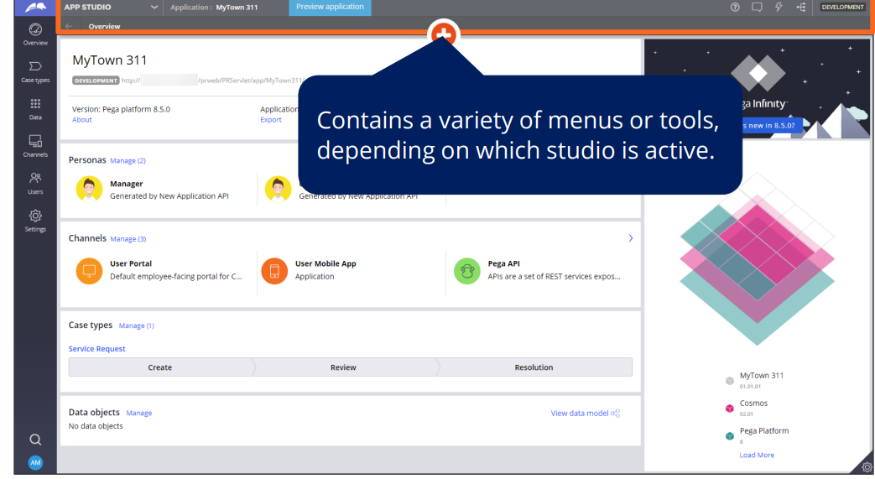

NAVIGATION PANE

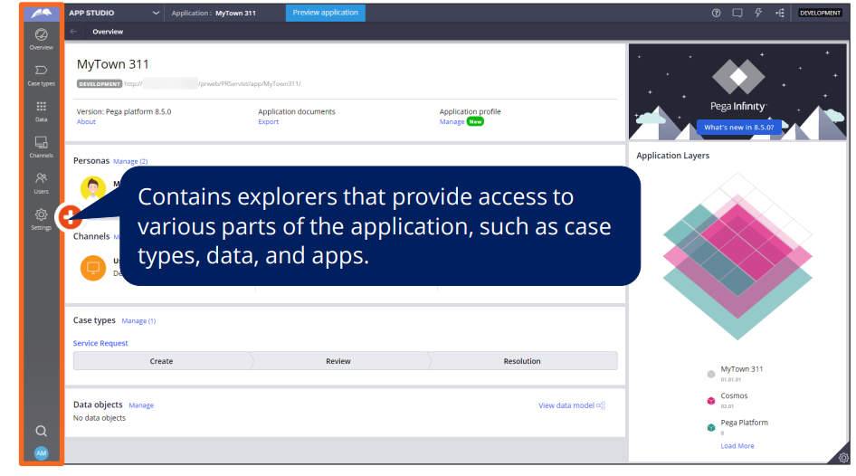

WORKSPACE

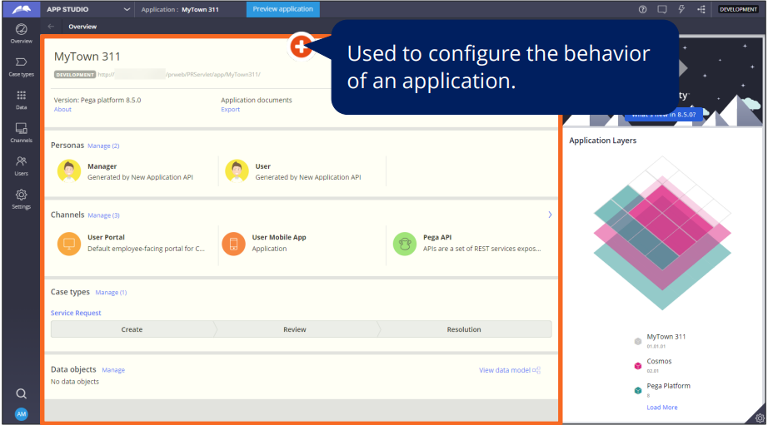

END USER PORTALS

* Case worker portal: Supports users who create and perform tasks on cases.
* Case manager portal: Supports users, primarily supervisors, who manage cases, their related sub-cases, and tasks

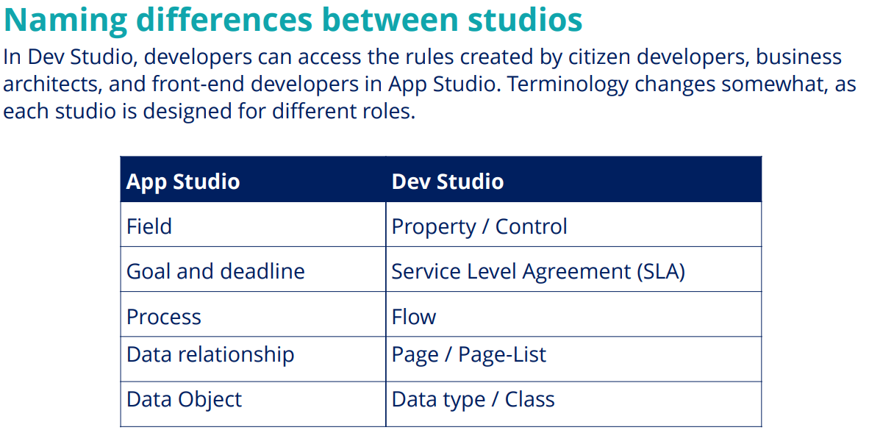

PEGA INTERVIEW QUESTIONS FOR PEGA PLATFORM STUDIOS:

1. What are the primary studios in Pega Platform, and what is their purpose?

**Answer**: The primary studios in Pega Platform are App Studio, Dev Studio, Admin Studio and prediction studio.

* App Studio is used for designing and configuring applications by business analysts and application designers.
* Dev Studio is for developers to work on the underlying code, integrations, and custom components.
* Admin Studio is for system administrators to manage, monitor, and configure the Pega application and platform.
* Prediction studio provides a dedicated home for data scientists within the pega customer decision hub. It provides a single module where they build and score models in real time, manage changes, and ensure every decision is relevant to the individual recipient

2. Can you explain the key features of App Studio in Pega?

**Answer:** App Studio allows for:

* Case design and modeling.
* Data modeling.
* User interface (UI) design.
* Business logic and automation.
* Collaboration and user management.
* Integration with external systems.
* Testing and simulation.
* Deployment and application lifecycle management.
* Security and access control.
* Reporting and analytics.

3. In Dev Studio, how do you integrate with external systems or APIs?

**Answer**: Dev Studio provides features for integrating with external systems:

* Connectors: Developers can create connectors for REST and SOAP services.
* Service Rules: Define service rules to manage interactions with external services.
* Database Integration: Develop database connectors and SQL queries to interact with databases.
* Java and Scripting: Write custom code to integrate with external systems and APIs.

4. What is the purpose of Admin Studio in Pega, and what are its key functions?

**Answer**: Admin Studio is used for system administration and management. Its key functions include:

* Application deployment and release management.
* User and access management.
* System health and diagnostics.
* Environment management.
* Security configuration.
* Batch processing and job scheduling.
* Security and compliance.
* Monitoring and reporting.

5. How do you build predictive models in Pega, and where can you use them?

**Answer**: You can build predictive models using tools like Prediction Studio within Pega Customer Decision Hub. These models can be used in decision strategies within App Studio to make dynamic decisions based on real-time data.

6. Explain the importance of version control in Dev Studio.

**Answer**: Version control in Dev Studio, typically integrated with Git, allows developers to manage source code, track changes, collaborate with team members, and ensure code quality. It helps maintain a history of code modifications and supports concurrent development.

7. What are the benefits of using Pega's low-code approach in App Studio?

**Answer**: Benefits of using Pega's low-code approach in App Studio include:

* Faster application development.
* Reduced dependency on traditional coding.
* Enhanced collaboration between business and IT teams.
* Easy customization and scalability.
* Reduced development and maintenance costs.

8. How do you ensure security in Pega applications, and what are some security features?

**Answer:** Security in Pega applications can be ensured by:

* Configuring access control and authentication.
* Implementing security policies and encryption.
* Regularly monitoring and auditing security events.
* Applying patches and updates to address vulnerabilities.
* Enforcing best practices in secure coding.

9. What is the purpose of the Case Designer in App Studio?

**Answer:** The Case Designer in App Studio is used to define and design case lifecycles, stages, steps, and processes within your application. It helps model and optimize how cases or workflows progress through your application.

10.How does Pega Platform support continuous integration and continuous deployment (CI/CD) in Dev Studio and Deployment Manager?

**Answer**: Pega supports CI/CD by integrating with Deployment Manager in Dev Studio. Developers can create deployment pipelines to automate application promotion across environments. Version control and automated testing are key components of this process.

1. What do you mean by workspace or studio in the context of pega?

**Answer**: A workspace is a place where you can use specialized and functionalities. You may let team members focus on tasks that fit with there expertise by using different workspace to create and administer your application

1. What are Benefits of App Studio ?

App Studio is designed for everyone, and it enables you to build more through composition, templates, and reuse.

Enablement

* Easy on-ramp for new users
* Contextual help & tours guide self learning
* Samples introduce application constructs

Collaboration

* Easily capture application intent
* Build out the higj-level case structure and process
* Seamlessly move between Express&Designer Studio for full configuration access

Innovation

* Rapidly build out new application concepts
* Leverage enterprise assets (data integration ,SSO ,Org structure ,etc)
* Full UX/design/mobile support

1. What are differences in naming between App Studio and Dev Studio ?

* The following table lists App Studio and Dev Studio terms

|  |  |
| --- | --- |
| APP STUDIO TERM S | DEV STUDIO TERM S |
| Data object | Data type |
| Field | Property |
| Landing page | Harness |
| New user | New operator ID |
| People, users | Operators |
| Persona | Access group |
| Single record data or case reference | Page property |
| Multiple data or case references (list of records) | Page List property |
| Single record query | Page property |
| Multiple queries (list of records) | Page List property |
| Single record embedded data | Page property |
| Multiple records embedded data | Page List property |
| Team | Work group |
| Work queue | Workbasket |
| Goal and Deadline | Service Level Agreement(SLA) |
| Process | Flow |
| Data Relationship | Page/PageList |

1. What are difference between App Studio and Dev Studio?

* AppStudio allows for a quick start with low-code features and visual designer capability to capture business objectives directly, enabling quick prototyping. App Studio is an easier tool to use. However, with Dev Studio, developers can set up more advanced application behavior .

|  |  |  |
| --- | --- | --- |
| S.N.O | APP STUDIO | DEV STUDIO |
| 1. UI Authoring | Using the design templates provide easy UI configuration, such as cell level configuration, including labels, headers and basic tables, formats and visibility​ | * Styling, formatting and editing in runtime​ * Reporting with personalized dashboards and charts​ * Mobile location services, native buttons, attachments etc. |
| 2.Case Types | Application overview page summarizing Pega Express delivery assets: Microjourneys™, Personas & Channels, Data & Systems | * Built-in feature map, Pulse messaging for development teams and team gadget to see who else is editing assets​ * Publish to DevOps pipeline with comments, user and bug traceability​ |
| 3.Data Objects/Integration | * Visual data modeler with ability to review, search, and extend application data model and relationships​ * Integration landscape visualization of data types and source​ * Calculating and formatting email, phone, URL and simple data references | * Data imports from external systems and email account management​ * Simulated data and inheritance of complex data types and classes |
| 4.Channels and Personas | * Define and assign personas to available portals with user management of profiles​ * Organization modeling, add and assign work queues, and management for landing page based on privileges | Multi-channel dashboard with extensible channel types e.g. chatbots, voice assistants, NLP for conversation channels and social media marketplace channel integrations​ |
| 5 | Project Delivery Support Features:   * Integrated traceability with your user stories and application features​ * Generation of application documentation | Technical Quality:   * Automated unit testing​ – Pega Unit * Automated scenario testing ​ – Pega Scenario |

1. How many studio areas in pega platform studio?

* Header:variety of menus or tools depending on which studio is active
* Navigation pane:explorers that provide access to various parts of the application i.e.case type,data, and apps.
* Work space: used to configure the behavior of an application

1. What are the End User Portals available in Pega?

* Case Manager Portal: Supports users, primarily supervisors , who manage cases , their related sub-cases , and tasks
* Case Worker Portal: Supports users who create and perform tasks on cases.

1. What is Prediction Studio ?

Built in decisioning &AI power up applications built by Pega

* AI
* Next Best Action